24VAC

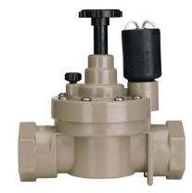

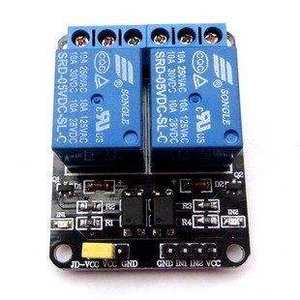

**Outlet**

**Relay**

**Pin 5**

**Inlet**

**Relay**

**Pin 6**

**Manual**

**Flush Button**

**Outlet**

**Solenoid**

**Inlet**

**Solenoid**





10K

**Outlet Sol. Open**

**LED**

**Inlet Sol. Open**

**LED**

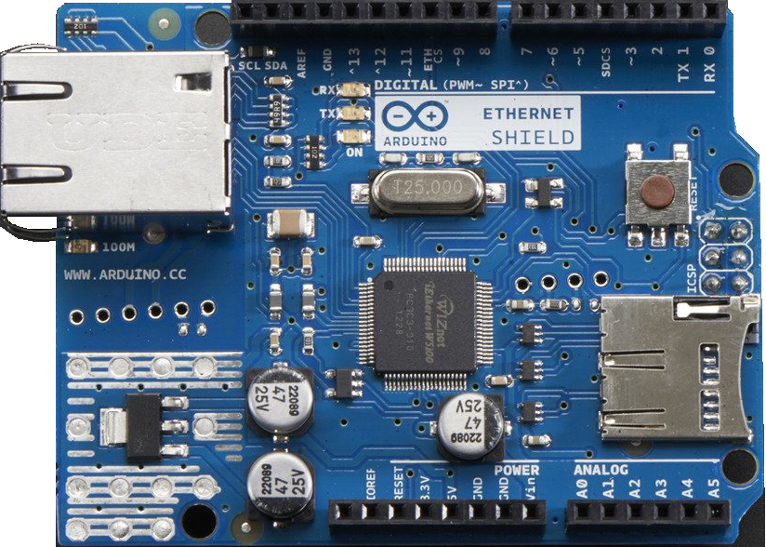



**On**

**LED**

S

+

-

S

220Ω

470Ω

470Ω

22K

220Ω

b

c

e

b

c

e

Network

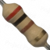

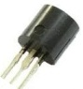

EMPTY

FULL

BC548C

BC548C

9VDC

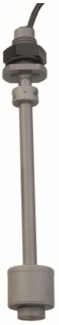

Make On Rise

Break On Rise

